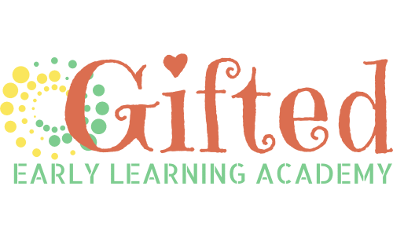
2023-24 School Year Tuition

Tuition includes Gifted’s Educational Programs, morning and afternoon snacks, and a nutritious lunch. Our goal is to recruit and retain highly qualified teachers and offer Gifted students extracurricular activities (art, music, technology, science). Current tuition prices do not include scheduled days off on the 2022-23 school calendar. Note: Students do not move up during the school year when their birthday occurs. Students remain with their cohort until the next school year.

CLASSROOM | ANNUAL REG FEE | 5-DAY (M-F) | 3-DAY (MWF) | 2-DAY (TTH) | DAY RATE
GIFTED INFANT  6 weeks to approx. 24 months | $150 | $695 | NA | NA | $33.50
GIFTED EARLY TODDLER  12 months to approx. 24months | $150 | $650 | $546 | $364 | $31.33
GIFTED ADVANCED TODDLER  24 months to preschool | $150 | $640 | $537 | $359 | $30.84
GIFTED EARLY PRIVATE PREK  Age 3 on or before 9/29/2022 | $150 | $625 | $525 | $350 | $30.12
GIFTED PRIVATE PREK  Age 4 on or before 9/29/2022 | $150 | $620 | $520 | $347 | $29.88
GIFTED AFTERSCHOOL | $65 | $266 | NA | NA | $28

